WEEK 1 TASK: DATA CLEANING AND PRELIMINARY ANALYSIS REPORT

1. Project Overview
* Intern Name: Ananya Rastogi
* Role: Virtual R Data Analyst Intern
* Organization: YuvaIntern
* Dataset Used: Olist Customers Dataset (olist_customers_dataset.csv)

2. Introduction
For the Week 1 task, the Olist Customers Dataset was selected to perform basic data ingestion, structure inspection, and preliminary analysis using R Programming. The primary objective was to check the structure, generate summary statistics, and identify any missing values within the workspace environment.

3. R Code Implemented
The following clean R script was executed in the Posit Cloud console to perform the analysis:

data <- read.csv("olist_customers_dataset.csv")

print("--- DATA STRUCTURE ---")
str(data)

print("--- DATA SUMMARY ---")
summary(data)

print("--- MISSING VALUES COUNT ---")
sum(is.na(data))

4. Key Observations & Summary Statistics
* Data Dimensions: The dataset contains a total of 99,441 records tracking customer locations across Brazil.
* Geographical Distribution: Customers are mapped across 27 unique states (customer_state) and 4,119 unique cities (customer_city).
* Data Integrity: The execution of the sum(is.na(data)) function returned a result of 0, confirming that there are no missing values (NA values) present in the dataset.

5. Output Evidence
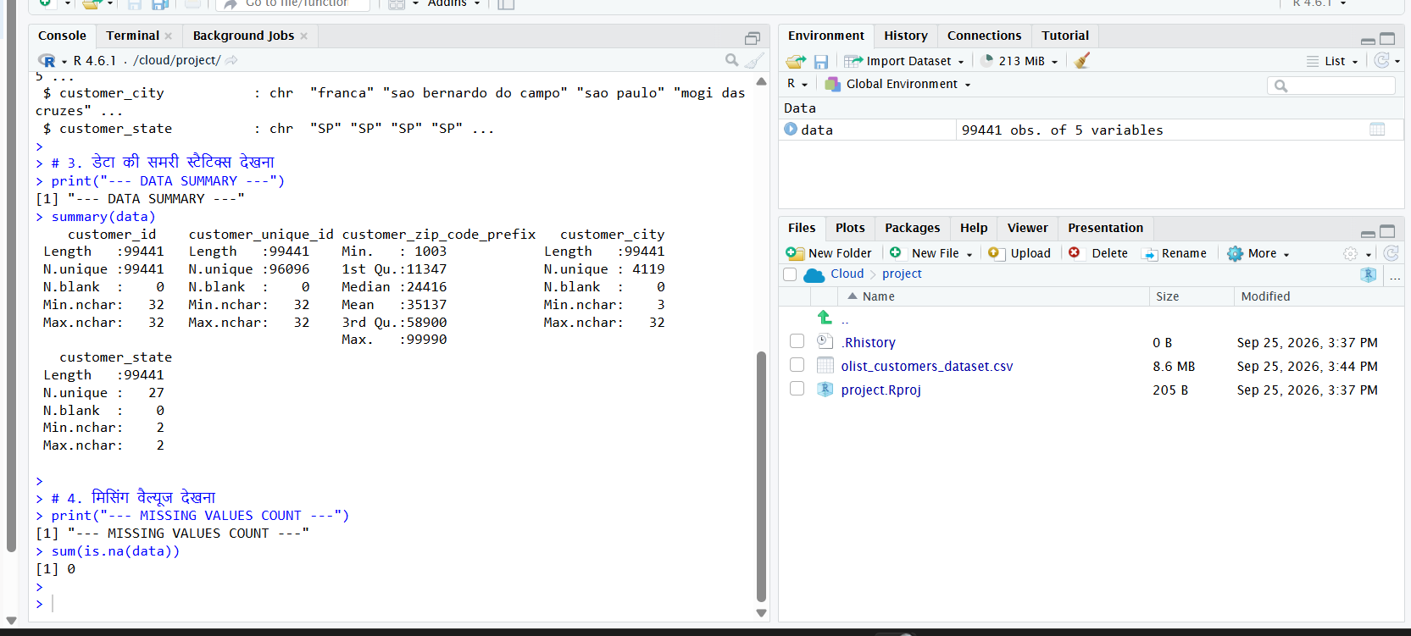
6. Conclusion
The data was successfully processed in the R environment. Preliminary operations such as structural validation and summary analysis confirm that the dataset is clean, structurally sound, and fully prepared for advanced predictive modeling or visualization in the upcoming weeks.

